Dear Agents,

Below you can find basic information how to Issue Voucher at the TAL Hotels (ukraine.talhotels.com).

Based on system rules, until Voucher issued the booking cannot be considered as sold and might be canceled by admin.

For all bookings you have sold to your customers pls issue vouchers as per below:

1. For **«Non-refundable» bookings -** at the same time while booking created. This boking cannot be refunded.

2. for bookings with **«Confirmed» status** - before cancelation deadline. If Voucher not issued bookings will **be canceled automatically**.

In case you didn’t get Voucher on your mail address ( registered for your account ) – you can duplicate voucher , see below :

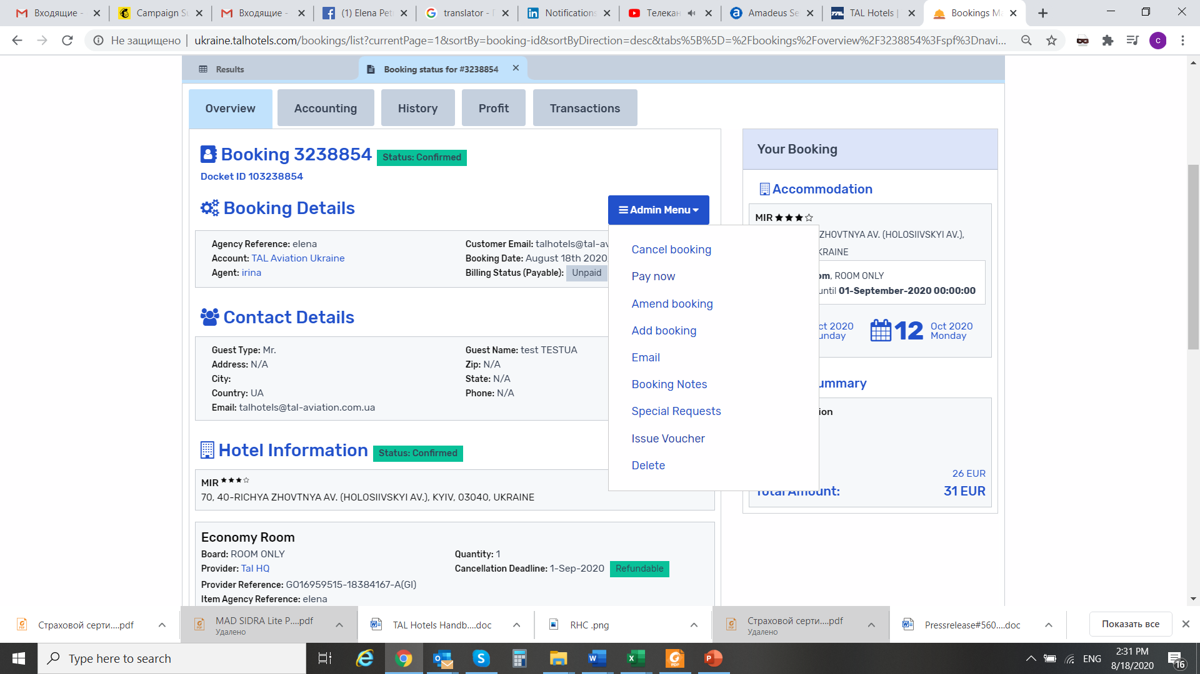

**Please use - Email from Admin Menu**

**Please use necessary document from the list - Documents to Email**

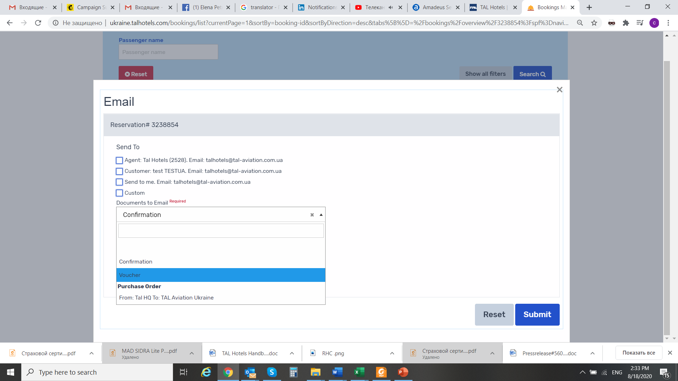

You can use any mail address and insert in manually, as well as text to your cent.

Example below:

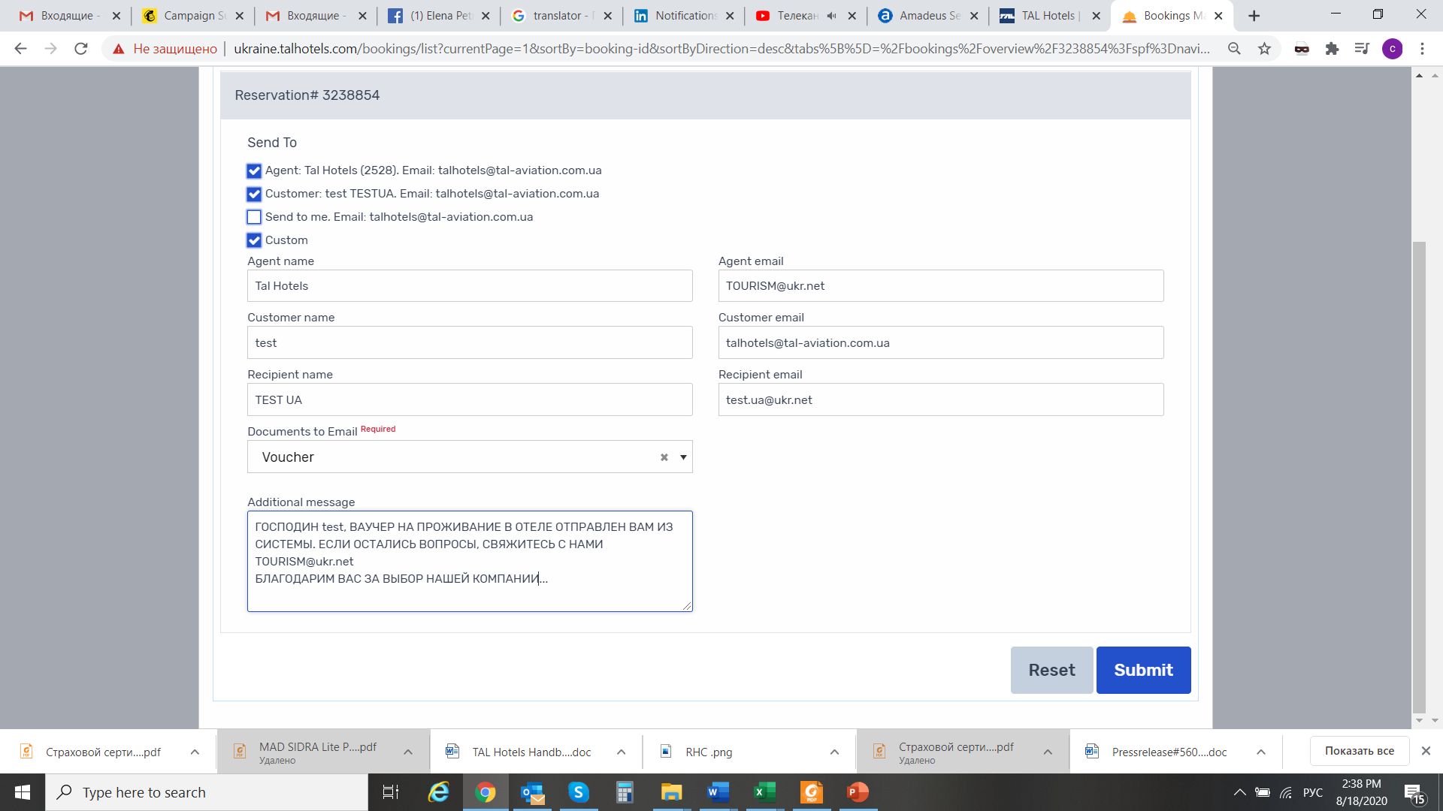

Voucher will come to the address without information about **the fare**.

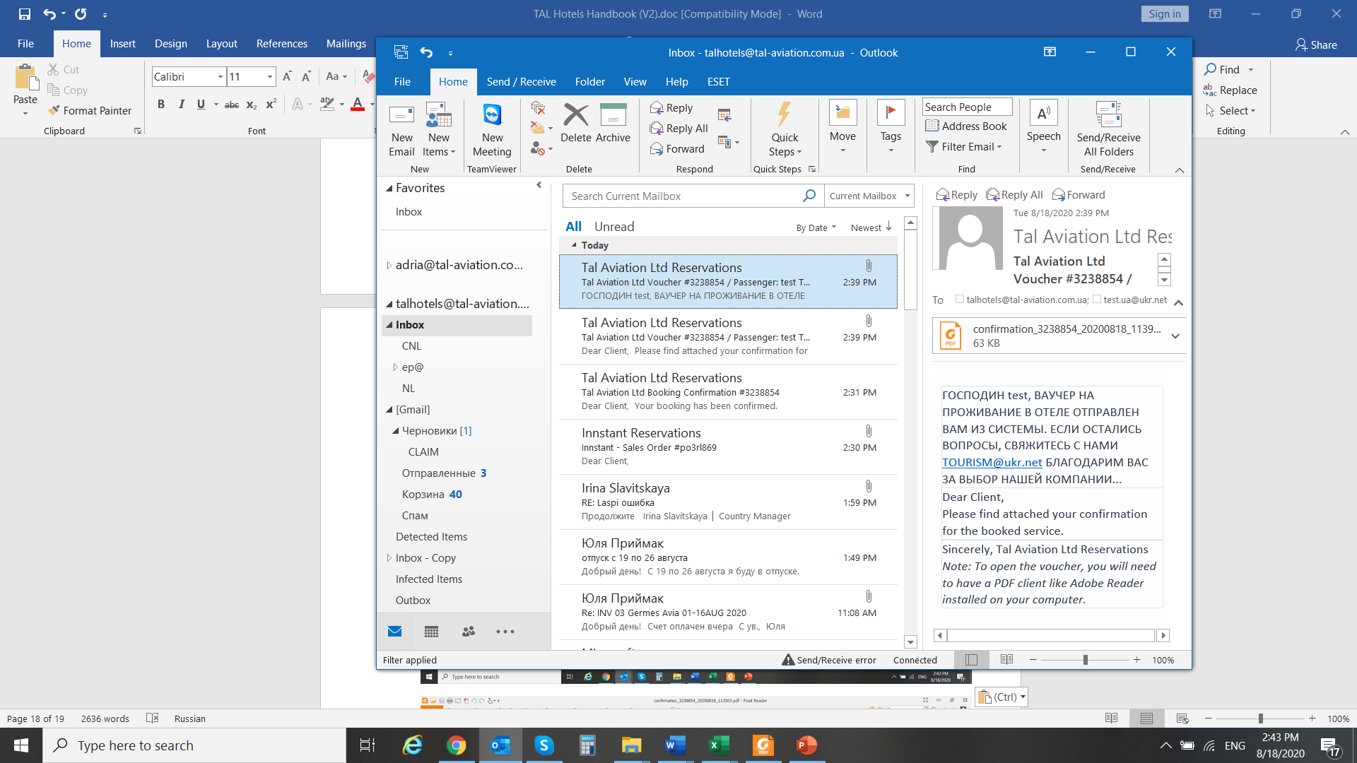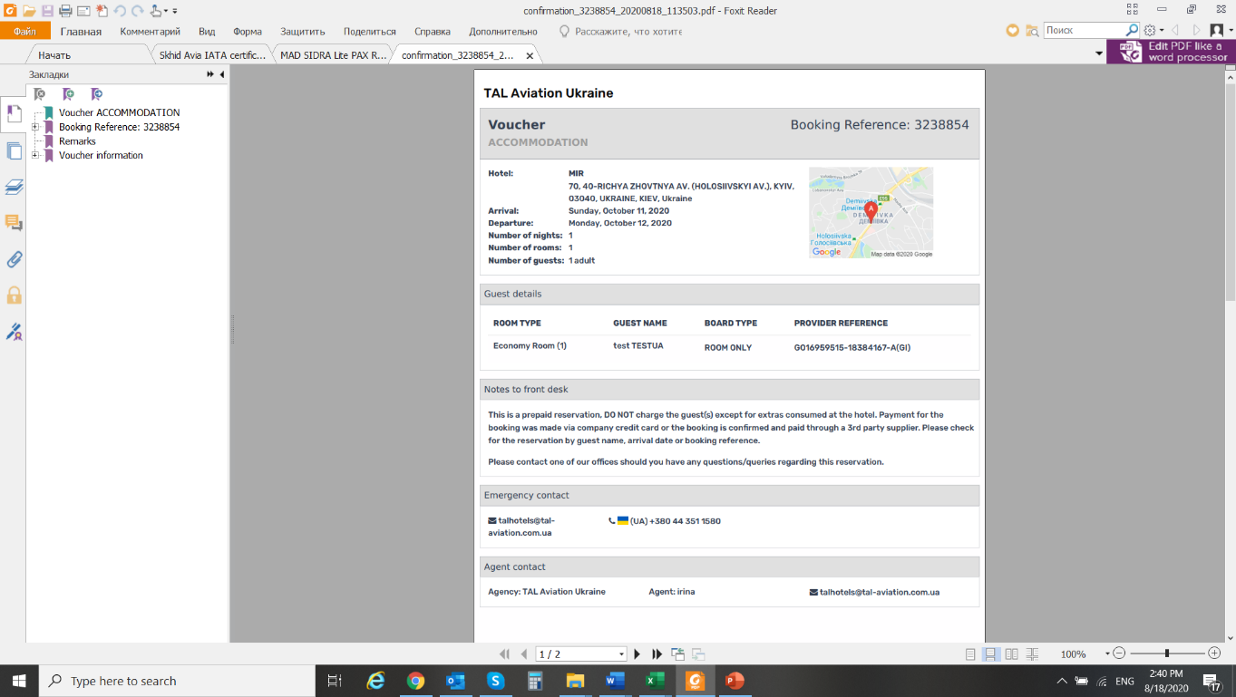

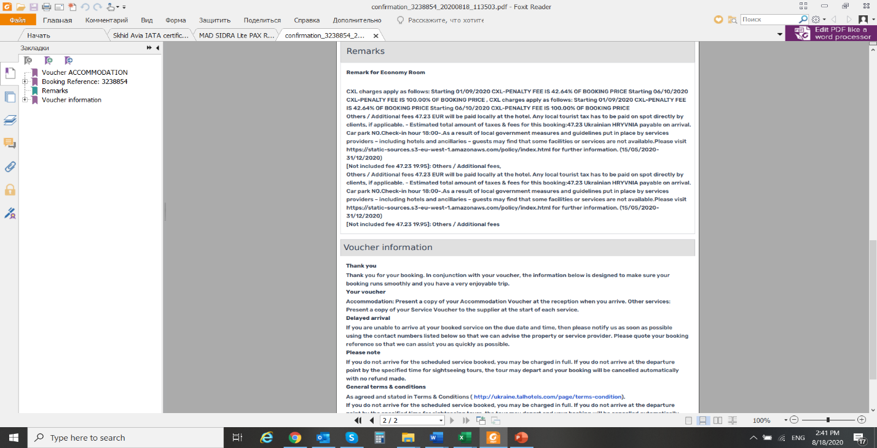

1. **In case you have created Refundable booking, please take care about TIME LIMIT and issue voucher before booking will be canceled by the system.**

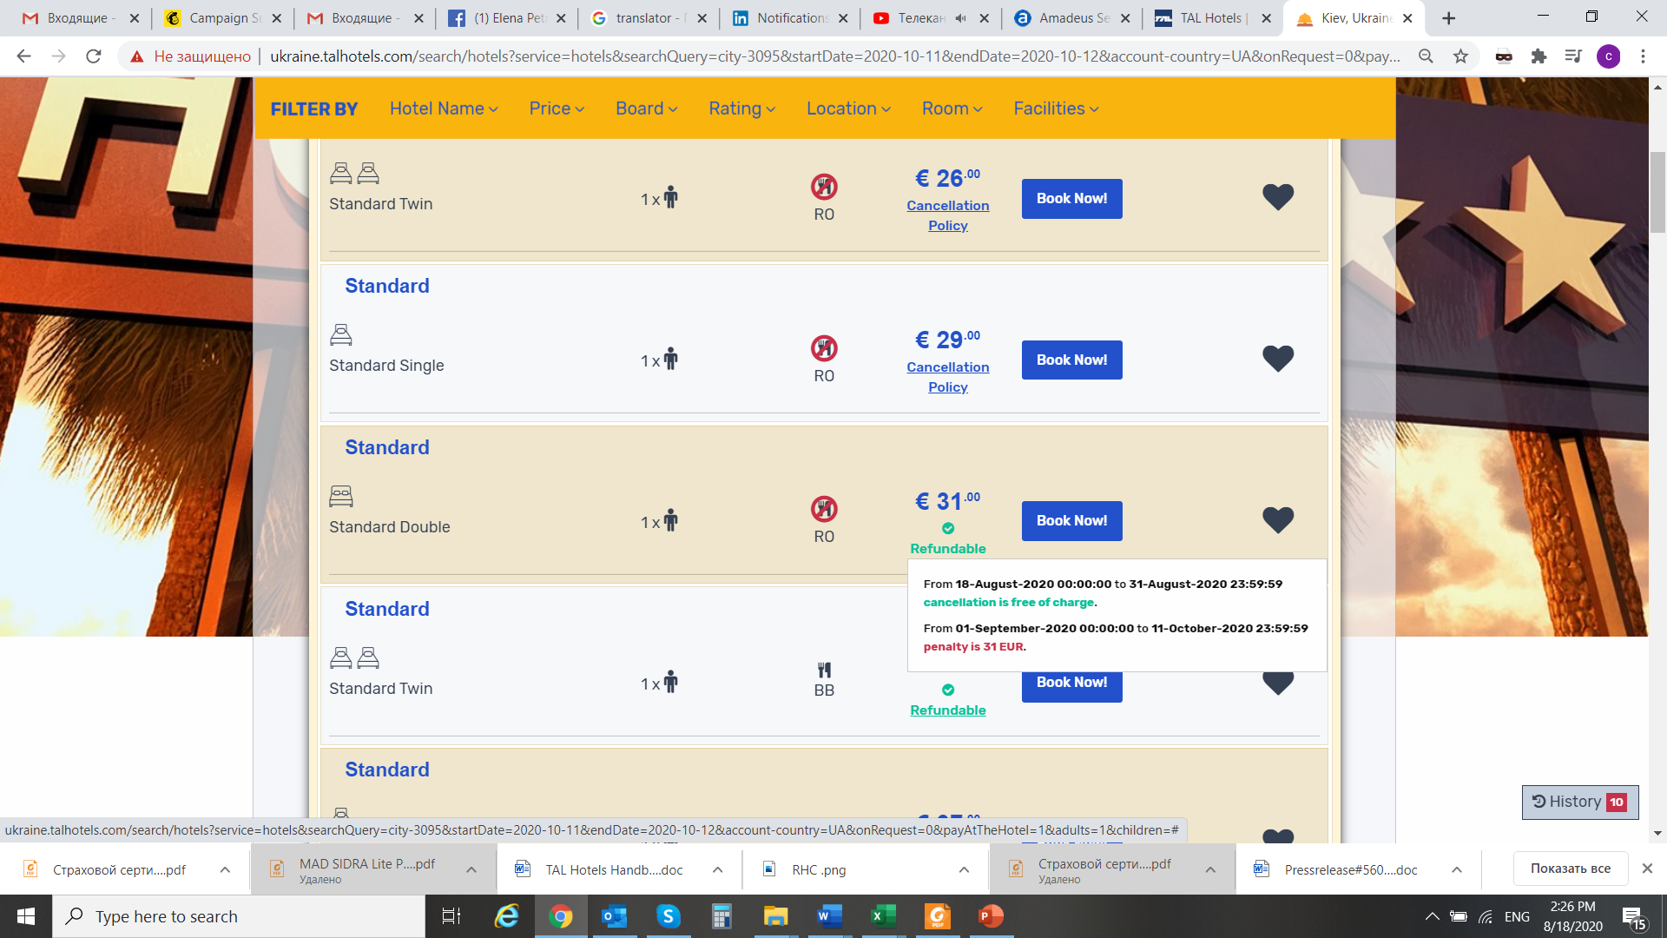

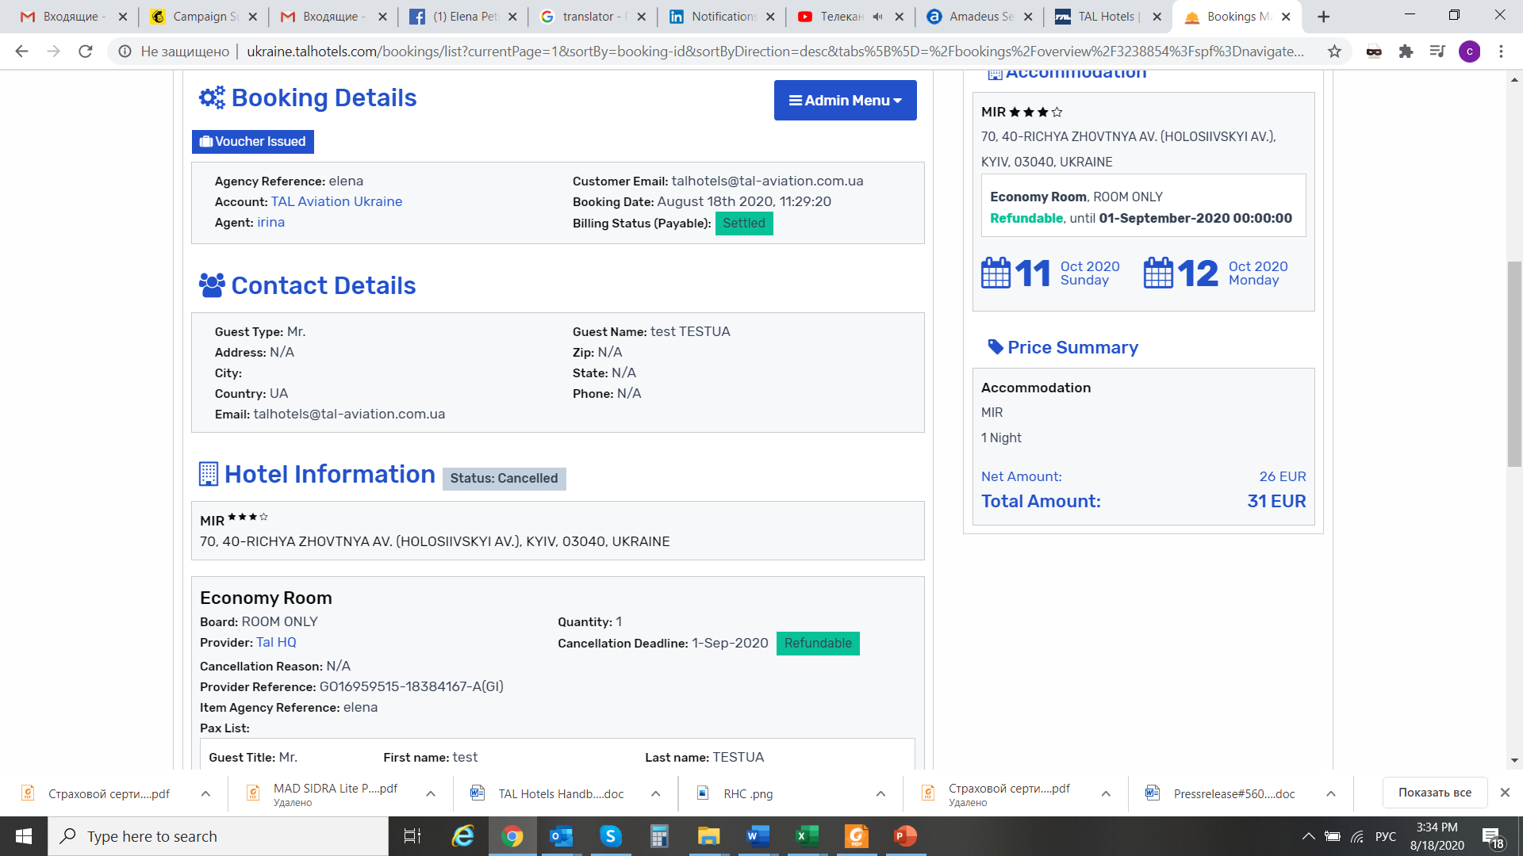

**Cancelation of the Refundable bookings!**

**Pls make sure that you cancel booking on time.**

**pls open the booking from the list and Cancel booking from Admin Menu**



**confirm cancelation**

