

**AdMIN KNOWLEDGE BASE**

1. **ACCOUNT SETUP**

**Introduction**

This page describes how to create an account for a travel agency .Innstant system is designed to work with **ONE** central account which can have multiple sub-accounts, one for each travel agency.

Please view sub-pages for Accounts setup topics.

**1. ADD ACCOUNT**

This document explains how to create an account on the Innstant system.

1. Log in to Innstant Platform.

2. Select **Admin** tab from the main menu and then select **Accounts**:

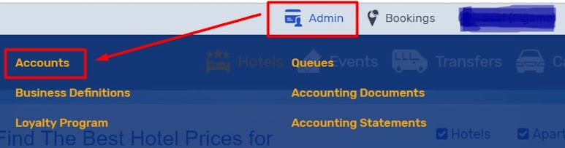

3. Once inside of Accounts Management page in order to create a new account click on Actions (blue button) and then click on **New Account** button:

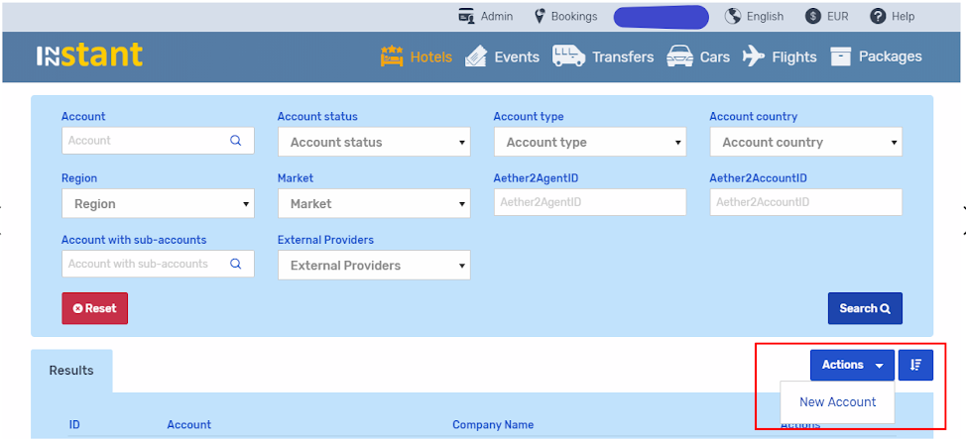

4. Tab **Add Account** will appear where you will have to input required information under General, Billing, and Documents tabs.

Please proceed to the next page.

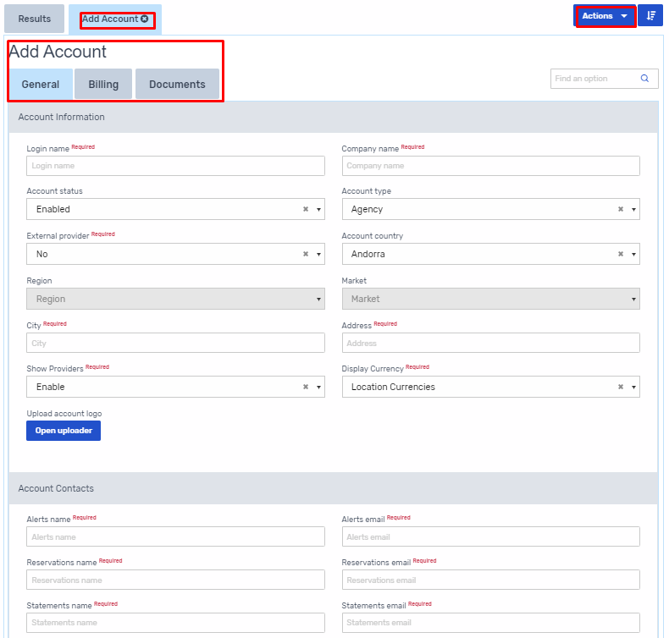

# 2. TABS (GENERAL, BILLING, DOCUMENTS, SETUP)

## 1. GENERAL

**Account Information**:

* + Login name - corresponds to account name when client logins into the website.
  + Company name - official company name that will be displayed on the system documents.
  + Account status - if the account is Enabled, the account is active. If account is disabled the account is not active and will not be able to place bookings.
  + Account type:
    - Agency - if account is setup as a travel agency account they will be able **to change markup** during booking process (Update customer price/markup)
    - Corporate - corporate accounts can only view "client price" during the booking process. Corporate accounts do not have an option to change the markup by using change customer markup tool.
  + Show Providers:
    - Important !!! Always Disable - accounts will not see the provider names
  + Display Currency:
    - * Account currencies - currency will be displayed based on the currency set under "Default currency" settings (Billing tab)
      * Selected currencies - currency will be displayed based on the currency that agents selects from the drop down menu ( EUR in our case )
* Fields marked in red are mandatory fields **(Required):**
* Upload account logo - If there is no custom logo uploaded then TALHOTELS as default will be used

**Account Contacts**:

* Alerts name/ email - define name/ email address where system alerts notifications are sent
* Reservations name/ email - define the main contact person for reservations handling and email address where Voucher, Sales Order and Invoice documents are sent
* Statements name/email - define name of the main contact person in Accounting Department and email address where payment demands / statements and account balance are sent

**Initial Relations**:

Setting initial relations between you and your new account (check the box where applies):

System automatically should offer below set up. Pls do not change it.

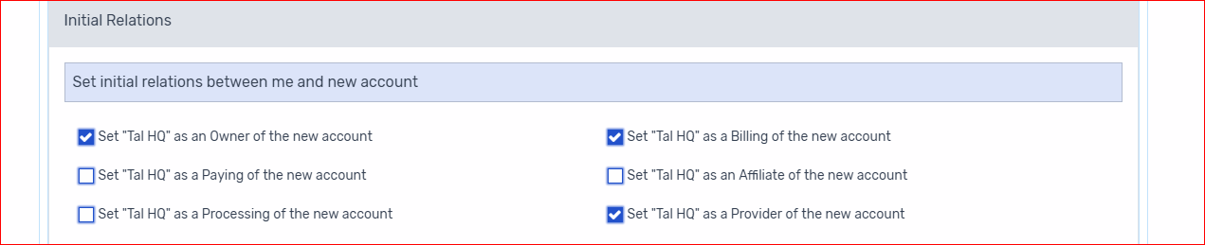

# 2. BILLING

**Account Billing**:

* **Defaulting account**
* “ No” account is considered to be defaulting when Forecasted Account Balance or Credit Used amount exceeds Credit Limit. Defaulting accounts should be blocked from making any bookings which are not paid immediately with a credit card.
* “Yes” account will no longer be able to make any reservations without entering credit card details.
* Billing cycle - relates to Account's billing cycle. It can be: daily; weekly; twice a month; or monthly
* Billing origin date - relates to Billing Cycle and defines the parameters of how the client will be billed
* Invoice issue date - date when the invoice will be issued. Invoice issue date should relate to the Billing Origin date definitions.
* Invoice due date - due date on the Invoice or Sales Order
* Default currency - the primary account currency
* Supported currencies - currencies that the account will be invoiced in
* **Guarantees & Guarantees amount**
* Guarantees - add guarantee option for the new account. You can choose from one of the options: Bank Guarantee, Deposit, or Credit Insurance
* Guarantees amount - add guarantee amount for the new account. If there is no guarantee amount please add zero (0).
* Processing account - if account is using the own payment gateway credentials, account is processing account
* Credit Limit Amount - amount of maximal allowed credit given to the account. Credit limit relates to cycle period.

**Auto Cancellation**

* Auto Cancellation - account’s reservations will be cancelled if the payment for the booking is not received 24 hours prior cancellation deadline (reservation will be cancelled if the billing status on the booking is **“unpaid” and “invoiced”).**
* If account is setup with "auto cancellation" flag, Bank Transfer accounts will still need to enter Credit Card details when making non-refundable reservations or if cancellation deadline is 120 hours (5 days) in the future. Credit card will be charged at the time of booking.

**Payment method**

* Cash
* Bank Transfer - statement (payment demand) is issued to accounts during regular intervals based on the payment terms
* Credit Card (fixed) - accounts / end client‘s credit card is charged for each reservation. When this option is selected, account will be able to save credit card details under the account settings.
* Credit Card (per booking) - account has an option to pay only with a credit card. For each booking credit card details will have to be added on the booking page.

# 3. DOCUMENTS

**Sales Order / Invoice settings**:

Display on SO/INV - three different template exist on the system:

* + Only Net Amount - Sales Order & Invoice will display only Net amount due for the booking
  + Net and Gross Amount - Sales Order & Invoice will display Net & Gross amount
  + Net, Gross and Commission - Sales Order & Invoice will display Net, Gross & Commission amount

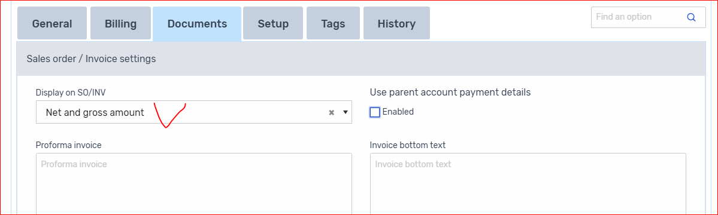

**Statement settings:**

* Statement remarks - free text remarks which will be displayed on the statement issued to the account
* Automatic statements - if checked automatic statement will be issued per account billing cycle
* User parent account statement remarks - if checked parent account remarks will be displayed on the statement

**Voucher settings:**

**Issue Voucher:**

* + - Automatically - vouchers are issued automatically for every transaction
    - Manually - voucher can be issued only manually by the Agent. When booking is confirmed, client will receive Booking Confirmation document but agent needs to issue the Voucher manually.
    - **Manually if paid** - agent is able to issue Voucher only if the booking had been paid.
* On voucher display full provider name - if checked, provider name will be displayed on the voucher
* Show provider contact details on voucher - if checked, provider's contact details will be displayed on the voucher

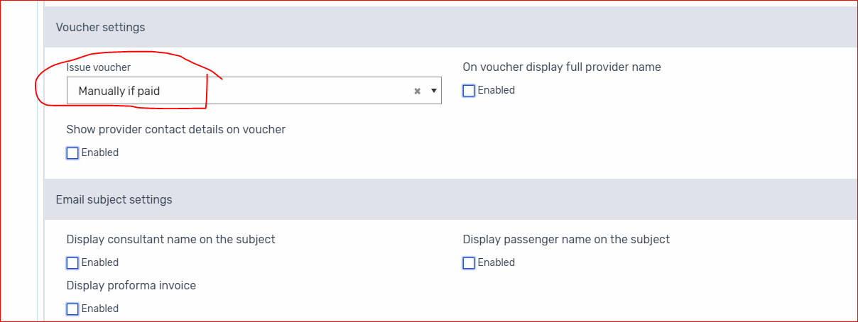

**Email subject settings:**

* Display consultant name on the subject - if flag is selected Agent name will be displayed in the subject line of the Voucher and Sales Order email sent to the Travel Agent
* Display passenger name on the subject - if flag is selected Passenger name will be displayed in the subject line of the Voucher and Sales Order email sent to the Travel Agent
* Display proforma invoice

**Document prefix**

* Documents prefix - option to add custom prefix which will be visible on the accounting documents
* Use source serial for billing documents
* Add Lead Name to Invoice and Receipt - if flag is selected lead passenger's name will be displayed on the Invoice and Receipt

Press the **Submit** button to create a new account. If you want to start from the beginning click on Reset button.

When the account was created you will receive a pop-up screen message "The action was completed successfully! ". Now you will see **Setup** tab where you will be able to see and set additional Account relations.

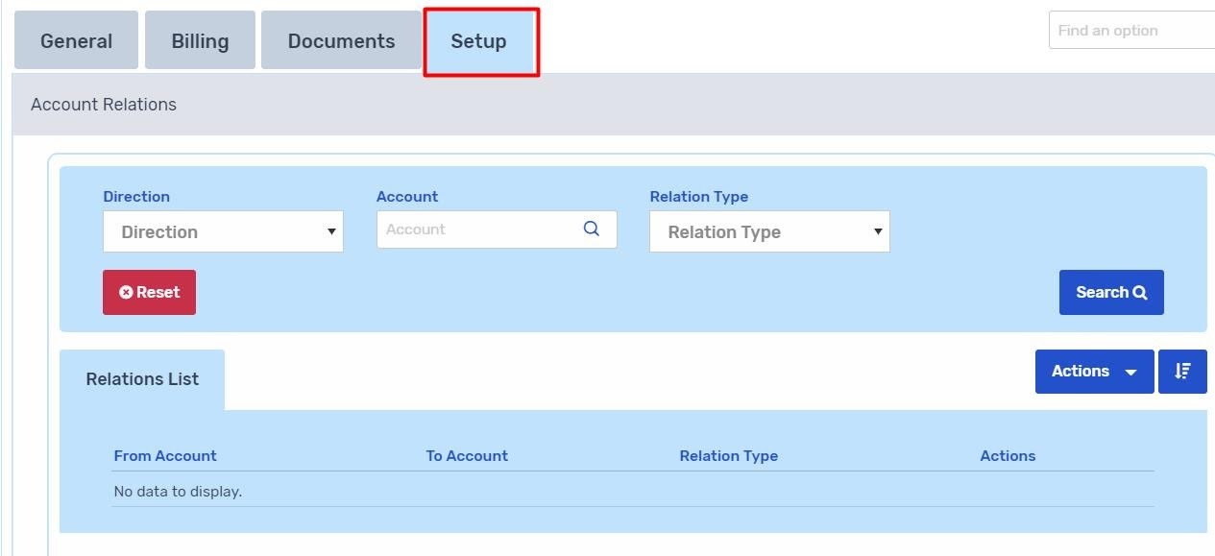

# 

### Account Relations

Under this section you will find more details on setup tab and plugin relations

* To create a new account relation click on Actions button and a new drop-down button will appear "**Add Relation**". Click on it.

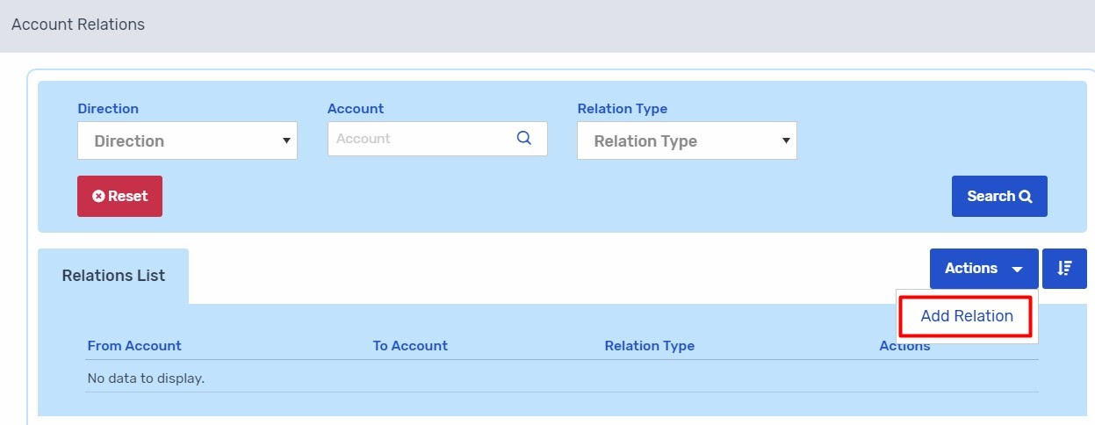

A new tab "Add Relation" will appear. It consists of 3 tabs (Relation Information, Billing Information, Plugin Information).

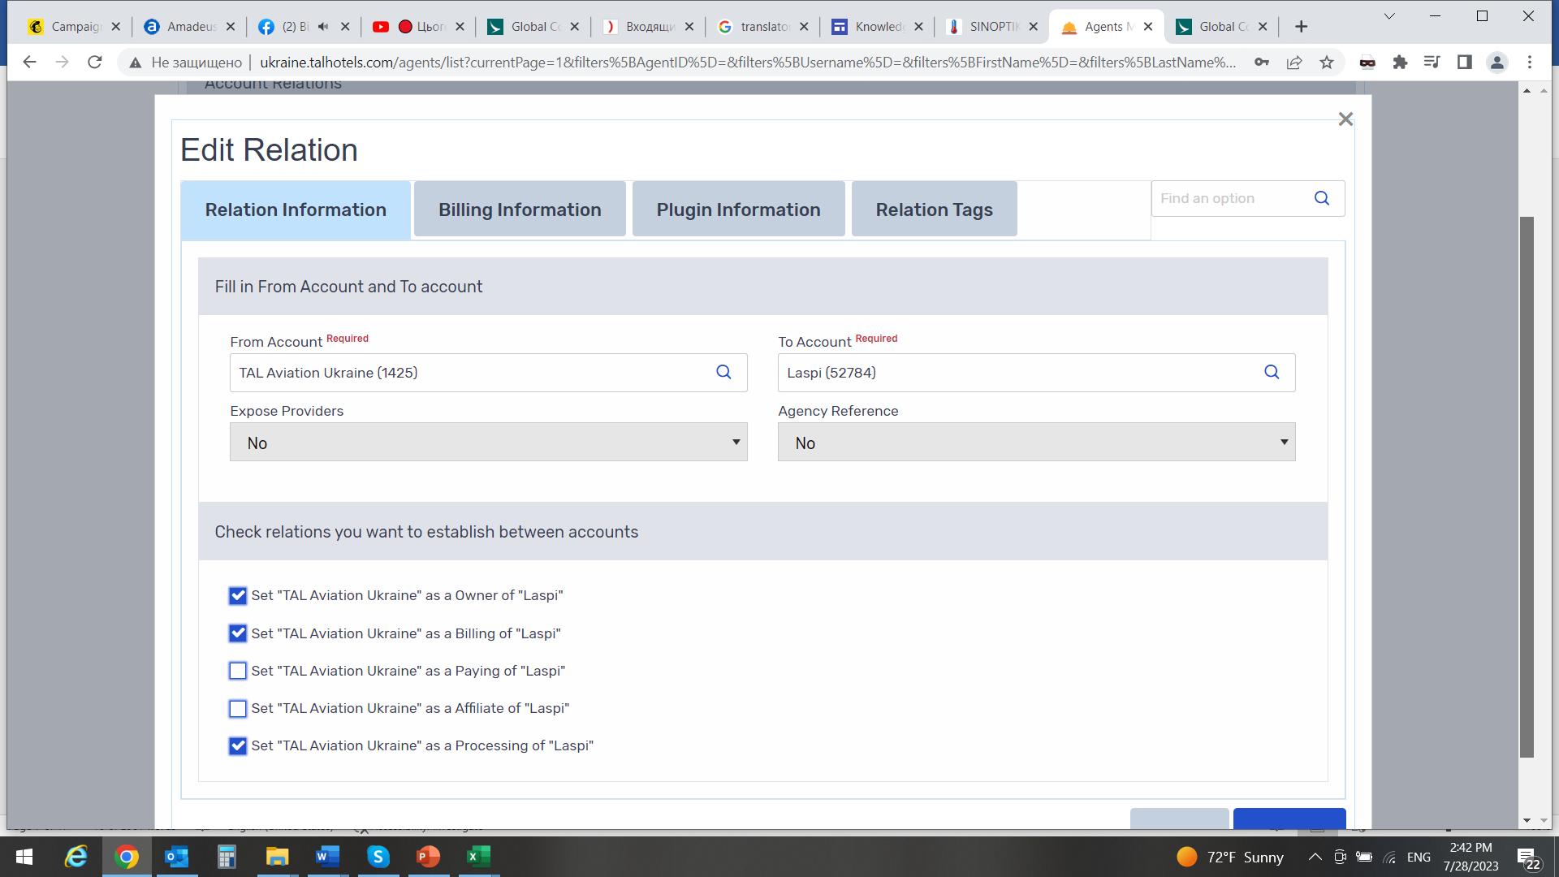

**Relation Information tab**:

* + From Account - account from which relation will be applied from. Please note that "From Account" field by default shows the account you are logged in. If you need to change the account inside "From Account" field, first remove the account which shows by default and then start typing the name of the correct account. A list of available accounts will show from the drop-down list. Select correct account.
  + To Account - account to which relation will be applied to. To add account start typing the account name and a list of available accounts will show from the drop-down list. Select correct account from the list.
  + Expose Providers - this field is related only to provider relation. If marked "Yes" account to which provider relation is being added will be able to see the names of the providers. If marked "No" account to which provider relation is being added will not be able to see the names of the providers.

**Billing Information tab**:

* + Billing information will be inherited from the account billing settings. It is important to add "Credit Limit Account" - this is relevant for Bank Transfer accounts.

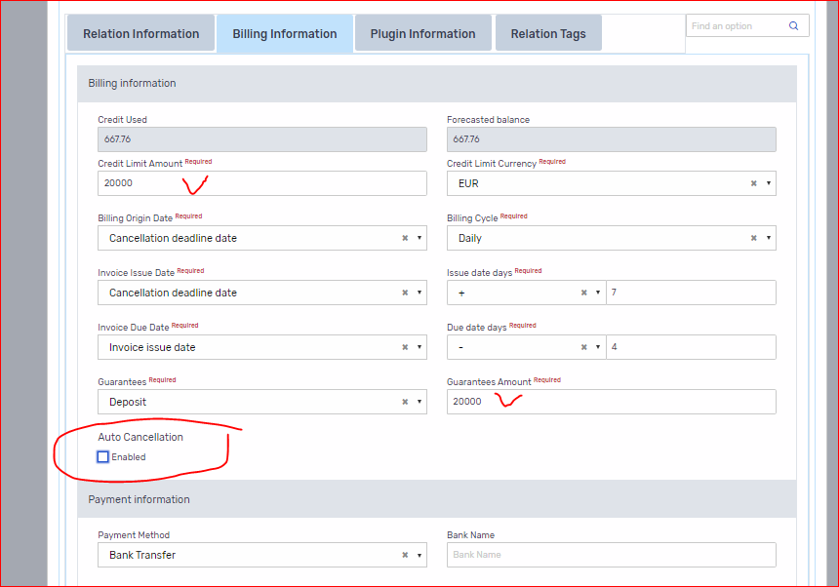

### Search Setup

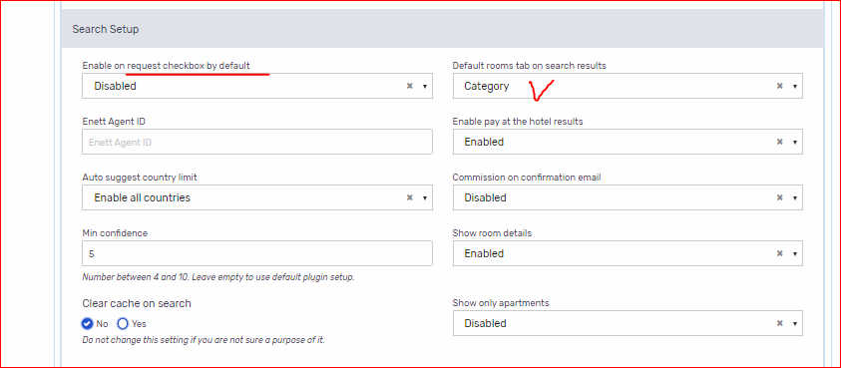

* **Enable on request checkbox by default** - if ***Enabled*** show on request results checkbox will be checked by default every time. It is located on home page search engine under Advanced Options. If ***Disabled*** on request results checkbox will not be checked.

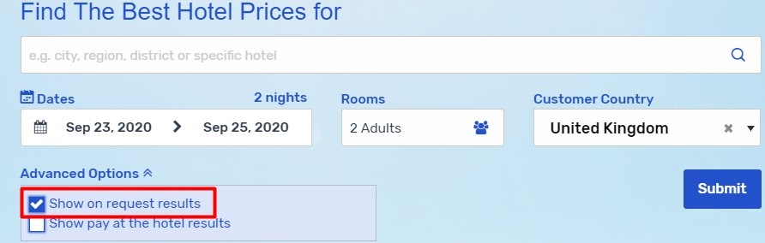

* **Default rooms tab on search results** - you can choose either ***Detailed*** or ***Category*** . If Detailed selected, detailed view room tab will be displayed on search results by default. If Category selected, category view room tab will be displayed on search results.

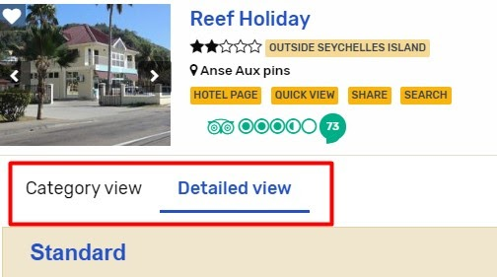

* **Enable pay at the hotel results** - if ***Enabled*** selected, users will receive pay at the hotel results (i.e. from Booking.com); if ***Disabled*** selected, users will not receive pay at the hotels results.
* **Auto suggest country limit** - this setting is used if you want to limit a country search for a particular destination under auto suggest search box (i.e. if only Canada is selected from the drop-down list, users will be only able to search for properties for destination Canada).
* **Commission on confirmation email** - if ***Enabled*** commission will be displayed on booking confirmation email. If ***Disabled***, comm. will not be displayed on confirmation email. Please note that commission first needs to be set under Business Definitions.
* **Min confidence** - it relates to Innstant mapping confidence. Please leave this field empty to use values configured in plugin settings.

**Business definitions**

1. Select **Admin** tab from the main menu and then select **Business Definitions**.

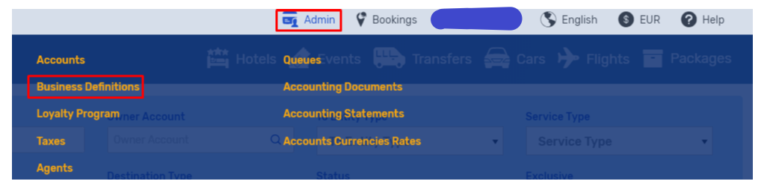

1. When you are inside of Markups Management page in order to create a markup click on **Actions** (blue button) and then click on **New Markup** button:

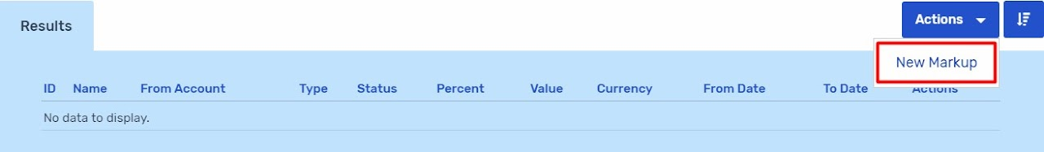

3. The **New Markup** window will show and you will have to enter required information (fields marked in red).

* Name - add a name of a markup
* Markup Status - ability to enable or disable a markup
* Markup Type
  + Net - markup is calculated from the net reservation price
  + Commission - calculated from the gross reservation price
  + Transaction Fee
* Percent - add a markup percentage
* Amount - amount value and amount currency are also mandatory fields. If you don't want to have amount value, please add "0" (zero).

When all information was added correctly, click on the **Submit** button.

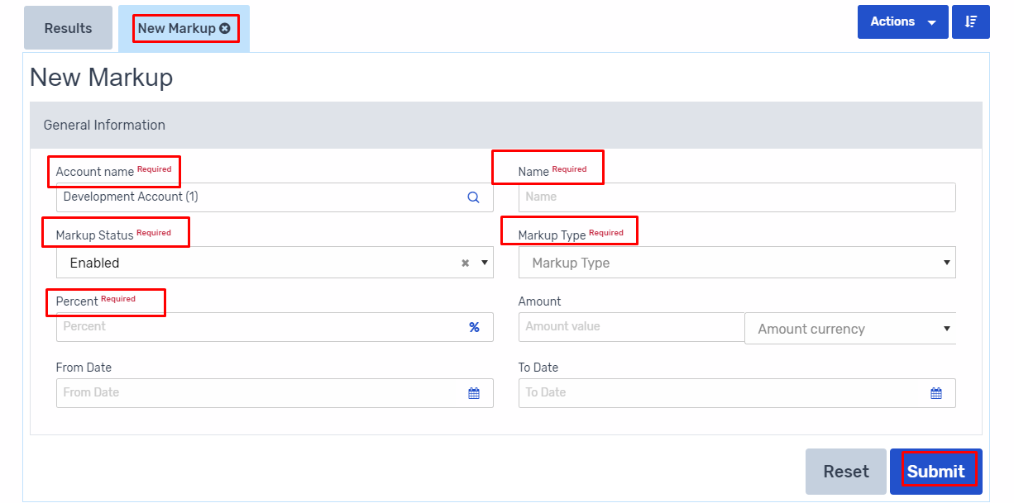

* 1. Once the general information was submitted, a new section will appear called "Destinations" where the user will define to which "Entity Type" (account, agent, service, etc.) markup will be applied. Click on "Actions" button and "Add new destination".

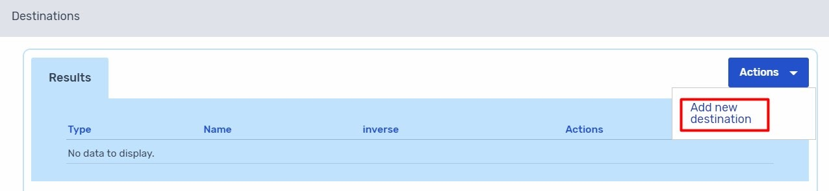

5. A new pop-up window will appear where the user can select one of the following entity types:

* Account
* Agent
* Destination country
* Origin country
* City
* Service
* Provider
* Customer

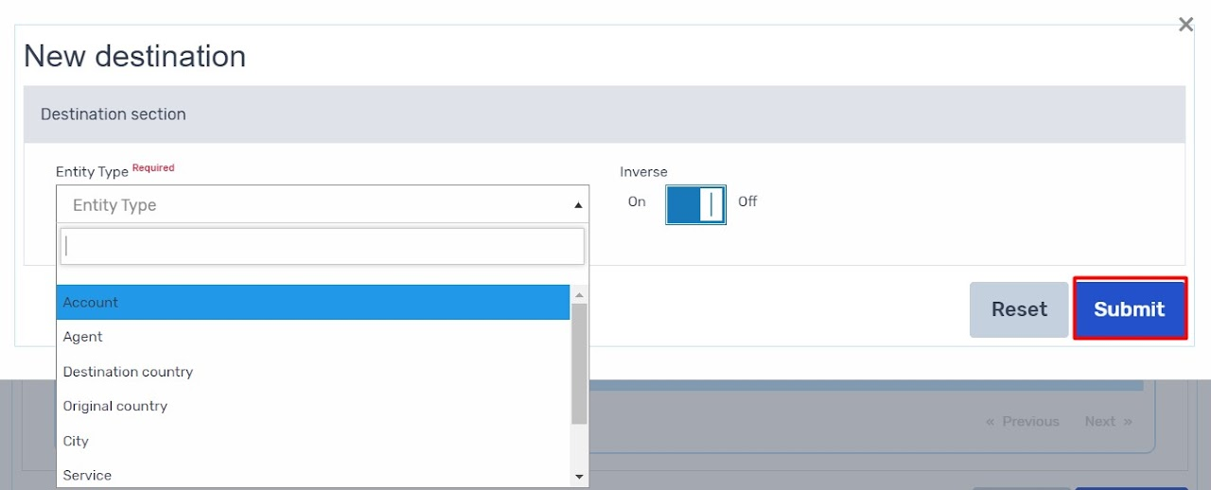

6.When the entity type was selected another field will appear where user will add the account name, agent, etc. to which the markup will be applied to. Once done click "Submit" button.

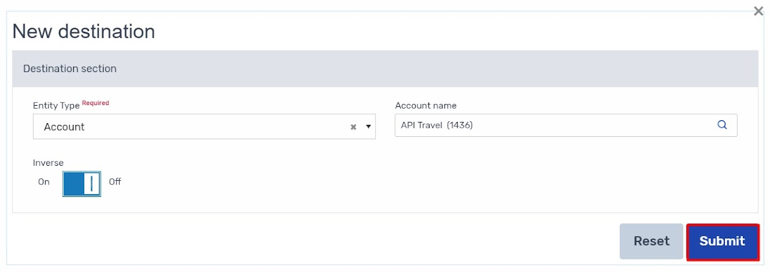

7. In order to edit the set markup click on the three dot image (blue icon) located under the "Actions" column and click "Edit Markup".

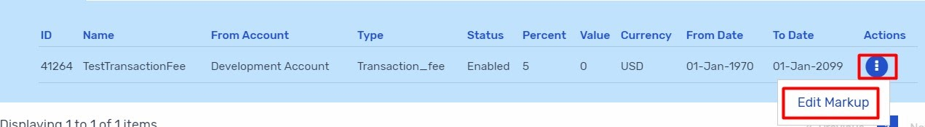

8. Other

Inverse - "Inverse" means the opposite in effect.

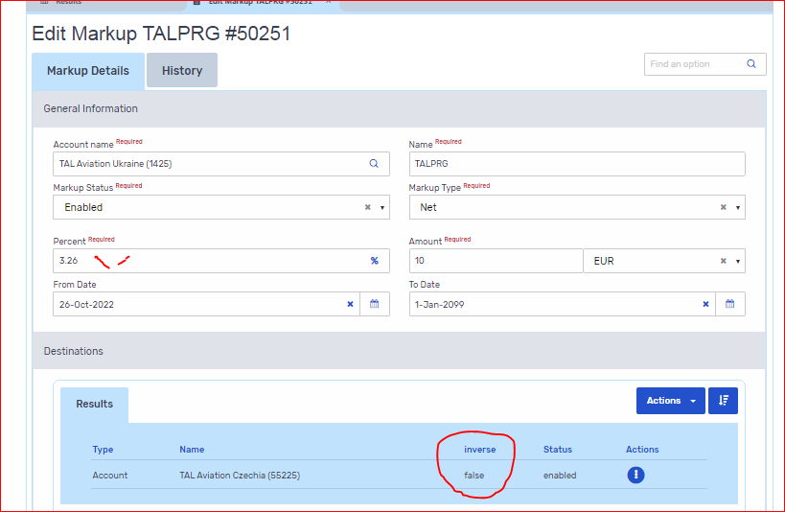

NOTE! Depending on how many sub-accounts has your account you can do MU amendment one by one. If the MU value is the same for the whole market, you to create one markup **from you to all sub-accounts**.

# 

You can use any of the provided Destination entity types but please be aware that in order to apply markup all rules (destinations) must match.

# AGENTS SETUP

Agents page provides explanation of system definitions related to setting up of new Agents (Users) in the system.

Select **Admin** tab from the main menu and then select **Agents**:

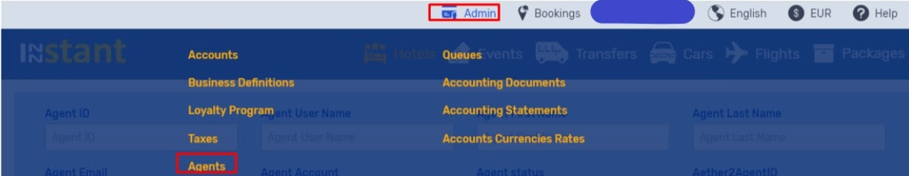

Once inside of Accounts Management page in order to create a new account click on Actions (blue button) and then click on **New Agent** button:

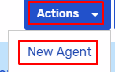

Tab **Add Agent** will appear where you will have to input required information under **General** and **Setup** tabs.

## 1. GENERAL

**General Information**:

* User Name - corresponds to Agent username on the login page
* First Name - first name of an agent
* Last Name - last name of an agent
* Password - corresponds to Password on the login page. Password details are encrypted and can not be viewed. If agent forgets his/her password details they will need to call you to enter the new password and save the details.
* Agent Status - an option to enable or disable an agent
* Email - each agent should have their own personal email. Same email address for multiple agents is not allowed
* Time Zone - time zone can be set per agents location

*All above fields are mandatory (required)

**Contact Information**:

* City, Address, Postal Code & Phone fields are required fields

### Search Information*:

* **Show Mark-up on search results** - an option to enable or disable showing a mark-up on search results page

*Search Information section will show only once the agent has been saved

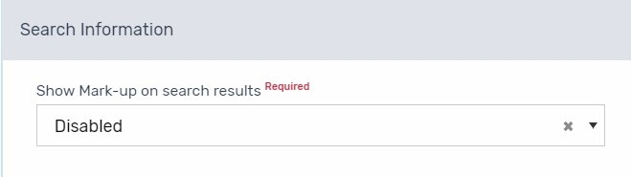

**Do not click on "Submit" button, proceed to Setup Tab.**

## SETUP TAB

## Account Relations:

* Under this section you are adding account relation - to which account the agent will belong to. Please note when creating a new agent by default the account under which you are logged in will be added to newly created agent. If you need to add agent under different account, first remove the account which was added by default.
* To remove (delete) account click on three dot icon and click on "Delete". A pop-up window will appear, click "Confirm" to delete the account.

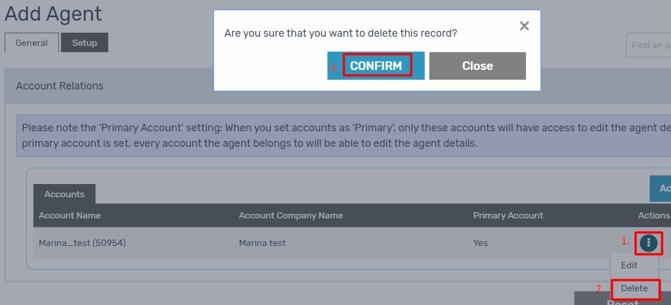

1. To add a new account under agent click on "Actions" and then click on "Add New".
2. A new field "Agent Accounts" will appear where you need to start typing the name of the account you want to assign to this new agent. From the drop down list select the account and click on "Save". Then click on "Submit" to save the new agent.

* Primary Account setting - When you set accounts as 'Primary Account' = "Yes", only these accounts will have access to edit the agent details. If you set 'Primary Account' = "No" every account the agent belongs to will be able to edit the agent details.

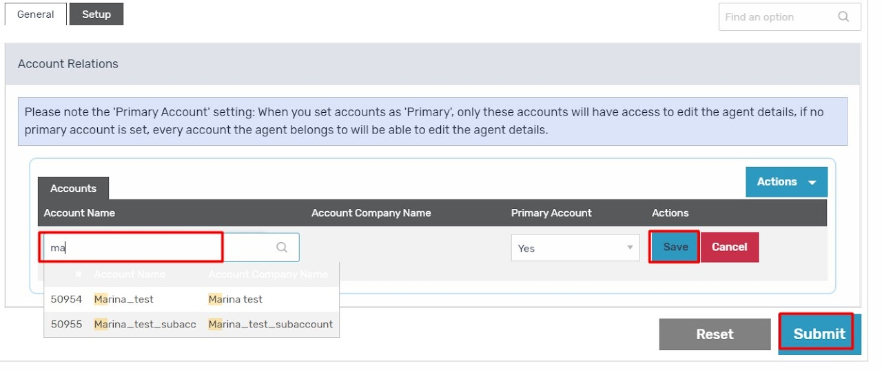

### Group Permissions*:

***\*this section will be visible only when the agent has been saved (submitted)***

1. On this section you have to add appropriate agent permission to the newly created agent. To add permission click on "Actions" button and then click on "Add permissions group".
2. A new window "Add Permission" will appear. Fill all fields and click on "Submit".

Explanation of each field find below screenshots.

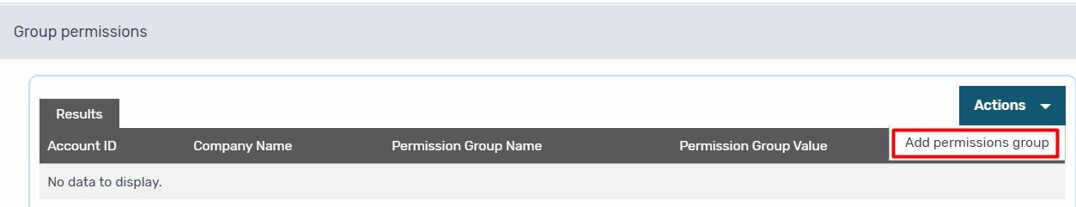

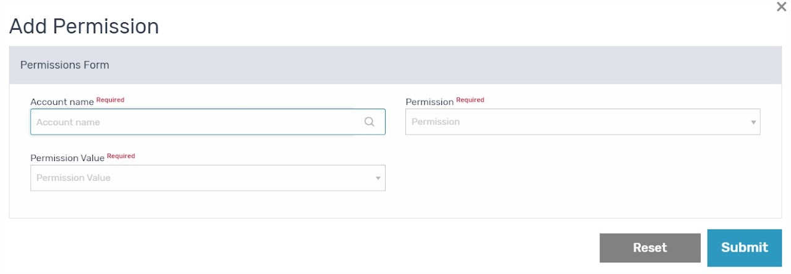

Explanation of fields under "Add Permission" window:

* **Account name** - start typing account name (of agent) and select it from drop-down list
* **Permission** - types of permissions:
  + Manager group - this is the highest level of agent permission. Agent with “managerial” permission will be able to set up the new accounts. Also, managers have an access to following pages: Accounts, Agents, Business Definitions, Queues, Taxes, Accounting & Currency rates.
  + Accounts
  + Observer - agent set up with observer permits will be able to view **rates** on the website but will not be able to confirm any bookings
  + Agent - agents set up with this permission do not have an option to set up the new agents in the system. Further, agents set with this permit will be able to view analytics report only for their own reservations but not for reservations made by other agents.
  + Individual Agent - permission for a single agent with a single account.
* **Permission value** - enabled / disabled